Phase 3 Walkthrough – Ride Sharing Analytics Pipeline

Objective
The goal of Phase 3 was to build an event-driven ride-sharing analytics pipeline using Apache Kafka. The system processes ride events, filters completed rides, calculates driver earnings, and displays the top-performing drivers.

Step 1 – Create Kafka Topics
Three Kafka topics were created:
- ride.events - stores all ride events.
- ride.completed - stores only completed rides.
- driver.earnings - stores driver earnings.

Step 2 – Produce Ride Events
File
ride_producer.py
Description
The producer reads ride data from rides.csv and publishes each record to the Kafka topic ride.events.
Output
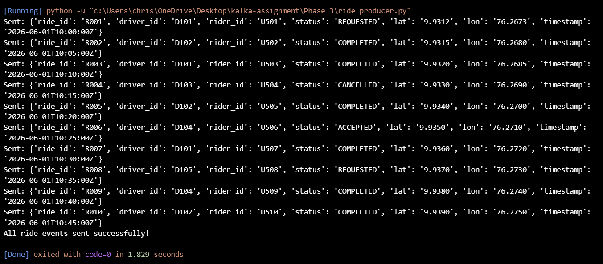
The producer successfully published all ride events to Kafka.

Step 3 – Filter Completed Rides
File
completed_consumer.py
Description
This consumer reads all ride events from the ride.events topic and checks the ride status.
Only rides with status = COMPLETED are forwarded to the next Kafka topic.

Output
Cancelled, requested, and accepted rides are ignored.
Only completed rides continue through the analytics pipeline.
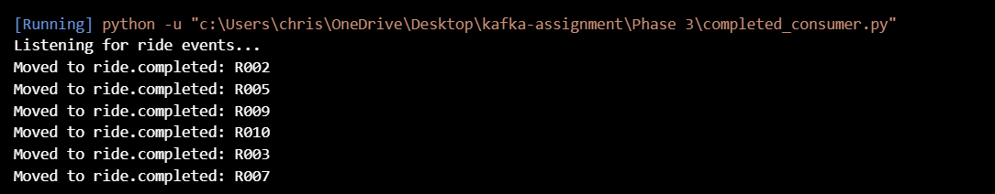

Step 4 – Calculate Driver Earnings
File
earnings_consumer.py
Description
The consumer reads completed rides from the ride.completed topic.
- Driver ride count is increased.
- Earnings are calculated.
- Earnings data is published to driver.earnings.
Output
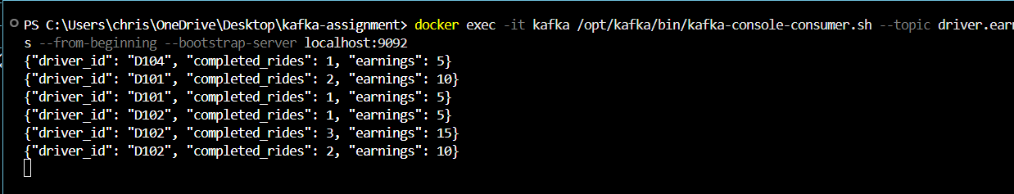
Driver earnings are continuously updated and published to Kafka.

Step 5 – Display Top Drivers
File
top_drivers.py
Description
This CLI application displays drivers ranked by completed rides and earnings.
Output

Top Drivers

Architecture Diagram
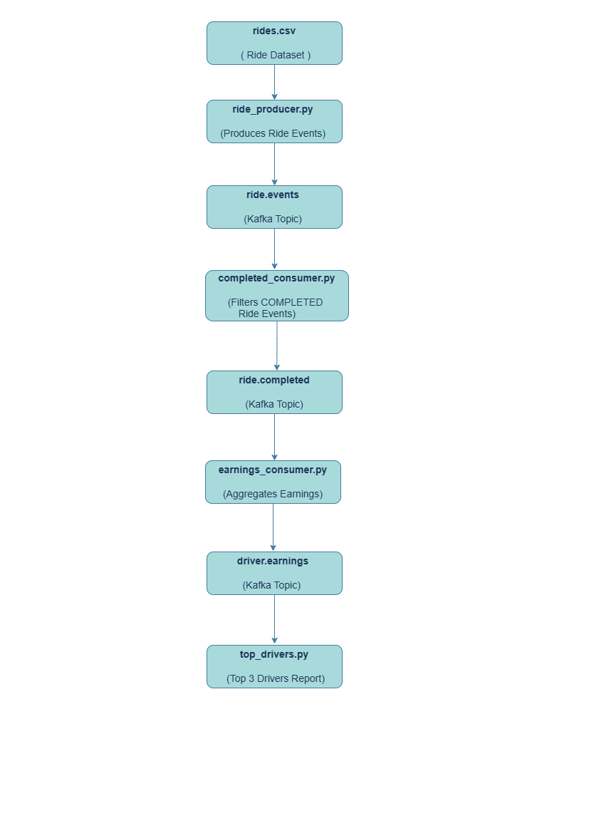
Conclusion
Phase 3 successfully demonstrated a multi-stage Kafka event-processing pipeline. Ride events were produced, filtered, aggregated, and analysed using multiple Kafka topics and consumers. The final output provided driver earnings analytics and a ranked list of top-performing drivers, showcasing the use of Apache Kafka for real-time data processing and event-driven system design.

